Agenda for Today:
- Topics from Last Week
- Migration Summary
- Update on Automation
- Curtisswright.com
  - Walkthrough of Weekly Web Analytics of Curtisswright.com
    - Google Analytics: Link
Summary Report For Migration Websites (Batch 3):
Website | Owner | Completed Tasks | Upcoming Tasks | Clarifications/Requests
CW Phase 2.0 - Planning | Sunil Kumar | Received pptx file from Darren.  Had a detailed discussed with CW-Defense understood their requirements  We analyzed the requirement of CW-defense  CW Defense — DS Web 2.0 : Requirements via Implementation - 20 Topics - Internal (To be shared with Dave)  Based on Weekly Discussion with the defense team, we are working on migration planning on merging Curtisswright.com and CW defense.  We will look at all the schema, data objects, and forms and do a detailed technical analysis on the merger of these two sites (including conflicts, issues, and naming or taxonomy changes).  Defense Analysis :  CW Web2 - Migration_Plan - DS | Internally discussed the design standards.  Creating a Drupal theme (CSS, JS specific to 2.0 mockups) will be installed on the 2.0 development site.  (Figma > Drupal Theme)  ---  Approved Templates by End of March 2026  (After Exec Review, Dev Starts by April 7th 2026) | Acquia environment setup for CW phase 2 ✅  https://cw-2-0-sandbox.curtisswright.com/sensors  CW Theme 2.0 ✅ (theme name : cw_2, cw_2_sub)  Modules ✅  Design ☑️  Phase 2.0 - Homepage Design preview Curtiss-Wright Phase 2.0 - Home page.pdfCurtiss-Wright Design product pages Web 2.0.pdf  Figma file link:  CW 2.0 Defense Product page updates  Web Phase 2.0 _ Navigation Corporate + Division.pdf  Brand Guide is completed ☑️  CW Web-2.0 Style guide updated.pdf  Style Guide_abbreviated.pdf (CW Copy)  We have reviewed the CW Style Guide.
CW Phase 2.0 : CW Common Theme Development | Sunil Kumar Britto Raj | Created 40 Components ✅  - Completed Home, Markets and Products Pages.  - All content is now editable using Layout Builder components.  - Completed the mapping of content types, site structure, navigation, Views, and the header and footer.  - Recreated the existing site using Layout Builder components.  - Login page designed | - Now working on products' inner pages. | https://cw-2-0-sandbox.curtisswright.com/sensors  https://cw-2-0-sandbox.curtisswright.com/cw-2-0-components-home  - I have some questions regarding the implementation of the News & Events and Contact pages.
Web refresh | Britto Raj Shilpa Patil | EMS - https://cwemscomstage.prod.acquia-sites.com/  Valves -  https://cwvalvescomstage.prod.acquia-sites.com/  Nuclear - https://cwnuclearcomstage.prod.acquia-sites.com/  Sensor - https://cwsensorscomdev.prod.acquia-sites.com | EMS - Completed ✅ Under testing ☑️  Valves - Completed Color refresh for header, footer, menu and copyright section. Working on inner pages.  Completed inner pages(170/410) ✅  Pending inner pages (240/410) ✅  Nuclear - Started working on staging site ☑️  Sensor - Started working on staging site ☑️ | Testing is going on.  The EMS Staging link will be shared by Tomorrow.
Nuclear | Sunil | - Integrate ultra.energy (cwic.curtisswright.com)  - Integrate 3keysoft.com / ws-corp.com  - Integrate cw-connect.com  - Evaluate store.ultra.energy (cwicstore.curtsisswright.com) | WS-Corp Site Summary Document | It's on hold.
CWST Translation Sites/Content | https://surfacetechnologies.curtisswright.com/  Nihar / Sindhu | Completed the translations for the French, Polish, Spanish, Chinese, and German languages. ✅ | Phase 2.0:  We have started Hungarian translations for whole sites. ☑️  Completed Pages: 8/249. | Phase 2.0:  Working on the Hungarian translations for the whole site. ☑️
Searchstax | Rohan |  | A custom module is developed. ✅  https:/curtisswright.com/search | Analytics Report  The new module for the per-page Trending Now feature has been deployed to CW, Industrial, Actuation, Surface Tech., EMS, and Valves. ✅  Pending WIP ☑️  Defence, Nuclear, and Sensors  Defence: Advance pages->indexed ✅
CWST - RFQ & Searchable Approvals Database | Divya | https://cwstcomdev.prod.acquia-sites.com/searchable-databaseapprovals  TG Approvals 2025 | Ref : https://www.valencesurfacetech.com/approvals/  For Database Approvals -Waiting for Client Inputs. ✅  The database sheet will be shared by July 3rd week. | https://surfacetechnologies.curtisswright.com/contact-us/rfq  https://surfacetechnologies.curtisswright.com/contact-us/speak-with-a-technology-specialist  Completed the RFQ and Speak with a Technology Specialist forms, including translations for all supported languages. ✅  Added CC for all submissions to Bruce.  Went Live : 24th july
SEO Optimisation for curtisswright.com | Sofia Krishnan | - Completed fixing broken pages (4xx) for surface tech. ✅  - Completed updating Curtiss wright page title.✅ | - Working on image compression & meta description updation for Surface tech site.  - Ticket No : INC0224386 | Sofia is working on the SEO Analysis of CW Business Sites (We have completed Surface Tech earlier)
Everlube | Divya M | everlubeproducts.com | Everlube Site Summary Document | Evaluation of the site is completed and sent for review. ✅  No updates this week.
IMR test Labs  http://imrtest.com/ | Shilpa Patil | IMR Site Summary Document  Completed Layouts : 02/52  Completed Pages Migrated: 0/182 | Pending layouts: 50/52  Pending Pages : 182/182 | No updates this week  Migration will start after 2.0 web refresh.
Keronite | Britto Raj | keronite.com | keronite Site Summary Document | Evaluation of the site is completed and sent for review. ✅  No updates this week  Migration will start after 2.0 web refresh.

Summary Report For Live Websites :
Website | Open Items | Clarifications/Requests | Resolved Issues / New Updates
Curtisswright.com  https://curtisswright.com  Live ✅  Monitoring and Supporting. | No Open Issues |  | Content Updates on Curtisswright.com:  Weekly Content Summary - CW WS CoE - 30 July 2026
CWST  https://cwst.com  Live ✅  Monitoring and Supporting. | No Open Issues |  | No open items.
CW Sensors  https://cw-sensors.com  Live ✅  Monitoring and Supporting. | No Open Issues |  | No open items.
CW Industrial  https://cw-industrial.com  Live ✅  Monitoring and Supporting. | No Open Issues |  | No open items.
Sunrise PGDT  https://sunrise.pgdrivestechnology.com/  Live ✅  Monitoring and Supporting. | No Open Issues |  | No open items.
Support PGDT  https://industrial.curtisswright.com/en-gb/pgdt  Live ✅  Monitoring and Supporting. | No Open Issues |  | No open items.
SSRT  https://industrial.curtisswright.com/ssrt/user/login  Live ✅  Monitoring and Supporting. | No Open Issues |  | No open items.
Powerchair Manager  https://industrial.curtisswright.com/en-gb/powerchair-manager  Live ✅  Monitoring and Supporting. | No Open Issues |  | No open items.
CW Valves Group  https://valves.curtisswright.com/  Live ✅  Monitoring and Supporting. | No Open Issues |  | No open items.
CW EST  https://valves.curtisswright.com/en-us/EST  Live ✅  Monitoring and Supporting. | No Open Issues |  | No open items.
CW Nuclear  https://www.cwnuclear.com/  Live ✅  Monitoring and Supporting. | No Open Issues |  | No open items.
CW EMS  https://cw-ems.com/  Live ✅  Monitoring and Supporting. | No open issues |  | No open items.
CW Actuation  https://www.cw-actuation.com/  Live ✅  Monitoring and Supporting. | No open issues |  | No open items.
Sensors & Actuation  https://sensors-actuation.curtisswright.com/  Live ✅  Monitoring and Supporting. | No open issues |  | No open items.
CW Defense  https://www.curtisswrightds.com  Live ✅  Monitoring and Supporting. | No open issues |  | Cookie banner issue has been fixed and confirmed by James. ✅  Working on validating the Google Analytics cookie expiration settings based on James's recommendation.
CW Actuation Portal  https://portal.cw-actuation.com/  Live ✅  Monitoring and Supporting |  | Live: portal.cw-actuation.com | Price configurator for the new products: GSX, GSM, SLM, SLG, KX, T2X, R2G, R2M, RDG, and RDM (10 products) ✅  Pushed to live on 24th July.  Working on the changes requested by Bonnie and the testers ✅  Completed the new Forgot Password email template. ✅

Topics from Last Week
Topic | Details | Question/Clarification/Update
Few Low Priority Topics |  | CW August 2026 Events ?  Upcoming IR events  - Aug 5 (Wed)- IR will publish Q2 Earnings via website after market closes, ETA 4:30 pm ET  - Aug 7 (Thurs) - Q2 Earnings Call
Bluefly Topics  Accessibility & SEO Improvements  Performance Optimization | Rasheed suggested CW SEO Topics and Scope. | CW <> Bluefly <> Etag - Topics Tracker  - Autodiscover and missing blocks – Work in progress (1/6). ☑️Will be completed by today.  - Working on Press release Date appending with title for all press releases on live site. (Completed year - 2002 to 2020) ☑️ - Will be continued after 2.0 web refresh  - Webform Module: The Counter Problem ☑️ (Testing few Drupal modules to implement Queuing process) - Will be continued after 2.0 web refresh
CurtissWright - BotTraffic - Remediation - Tasks |  | CurtissWright - BotTraffic - Remediation - Tasks.xlsx Work in progress  P1 P2 P3 Total  CW 9 13 1 23  Etag 4 7 2 13  Total 13 20 3 36
Service Now |  | - Dev and stage url is unable to access.

Analytics, Monsido, and Webmaster Console:

Analytics | https://analytics.google.com/analytics/web/#/p432579895/reports/intelligenthome
Webmasters Console | https://search.google.com/search-console?utm_source=about-page&resource_id=sc-domain:curtisswright.com
Monsido (Acquia Optimize) | https://new.monsido.com/

Analytics
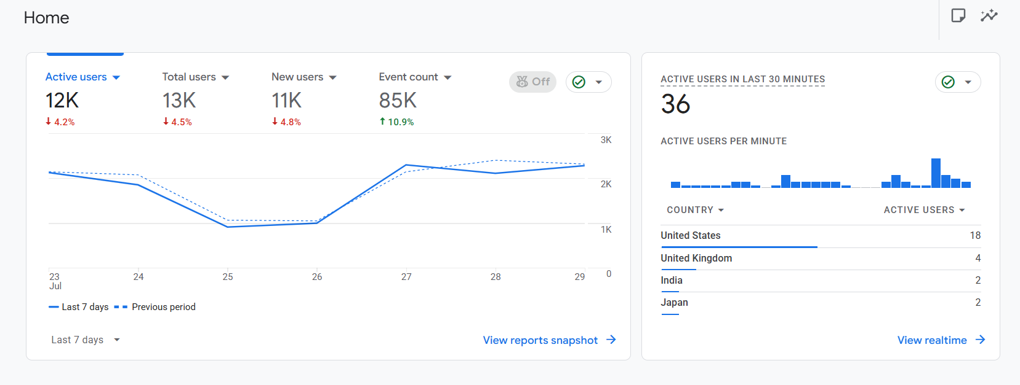

Monsido

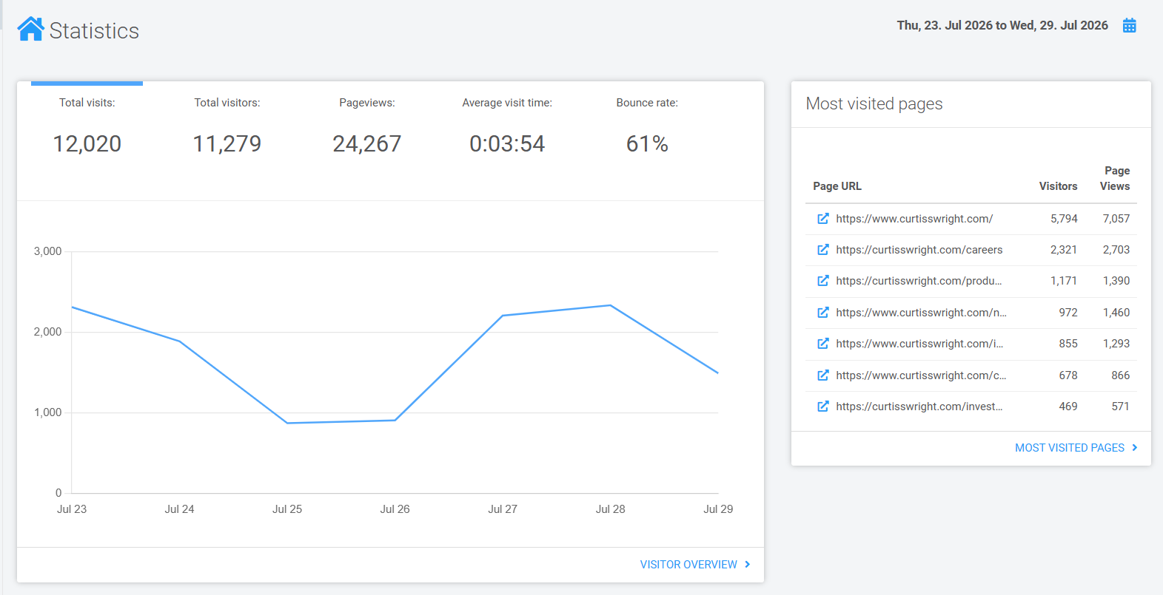

Search Stax
All Application
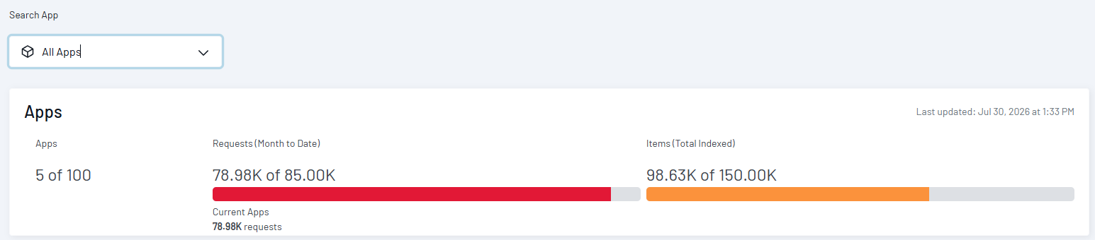
CW Live
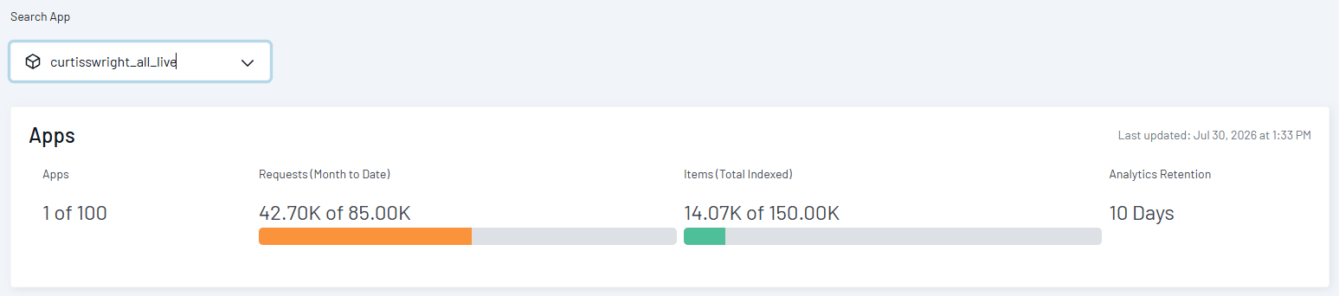
Inside CW Prod
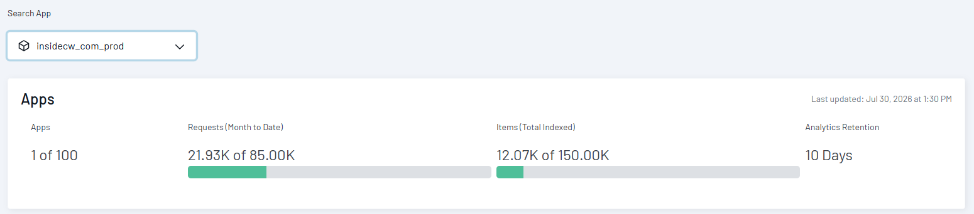

Dave’s priority list 2025

Topics | Owner | Status
Corporate - Add Veterans section to Careers | Divya M | Need to Start.
Global Search / Global Navigation | Sunil KumarRohan Gurav | - All the sites are now live with the SearchStax custom module implemented. ✅
Valves consolidation go-live | Divya MShilpa Patil | Went live ✅
Migration of cw-ssrt.com and powerchair-manager.com from Dreamscape (deadline approaching based on hosting) | Shilpa Patil  Britto Raj | SSRT went live ✅  Powerchair manager went live✅
Non-time-sensitive content change requests |  | Actively managed till 4PM EST Every Business day
CWST translations | Sindhu NJ  Nihar Ranjan Nayak  Divya M | Working on Hungarian translations. ☑️
Actuation portal improvements  Migration of tools.exlar.com | Rohan Gurav | LMS  - This feature is in the roadmap
Actuation translations | Sindhu NJ  Nihar Ranjan Nayak  Shilpa Patil | Translation is on hold.
Migration of 3keysoft.com | Sunil Kumar | Site Summary Document ✅  Waiting for the stakeholder’s response. As per our discussion, only 10 pages need to be added manually, so there is no need to start the migration now. Once they share the confirmation, we will start Migration.
Centralized ticketing system to allow routing content change requests for approval | Rohan Gurav | This feature is in the roadmap

